
SPONSORSHIP FORM
Name: ______________________________________________________________________________
For (event): ___________________________________________________ in aid of Kids Cancer Charity
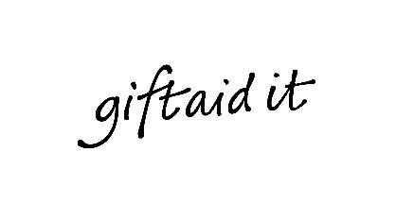
If I have ticked the box headed ‘Gift Aid? ‘, I confirm that I am a UK Income or Capital Gains taxpayer. I have read this statement and want Kids Cancer Charity to reclaim tax on the donation detailed below, given on the date shown. I understand that if I pay less Income Tax or Capital Gains tax in the current tax year than the amount of Gift Aid Claimed on all of my donations it is my responsibility to pay any difference. I understand Kids Cancer Charity will reclaim 25p of tax on every £1 that I have given.
Remember: You must provide your full name, home address, postcode and
Gift Aid for Kids Cancer Charity to claim tax back on your donation.

Sponsors  Full Name  (first and last name) | Sponsor’s Home Address  (Only needed if you are Gift Aiding your donation. Don’t give your work address if you are Gift Aiding your donation) | Postcode | £  Amount | Date  Paid |   Gift Aid?
John Smith | 1 Kids Cancer Charity Road, Swansea | EX1 MPL | £10 | 01/01/22
Total donations received |  |  | £
Date of donations given to Kids Cancer Charity

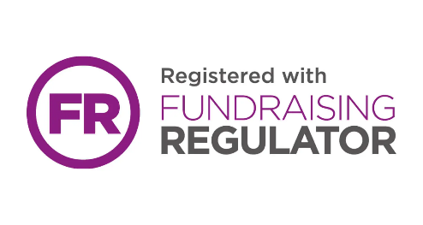
Please return all forms to:

Freepost KIDS CANCER CHARITY
(no other details required!)

T: 01792 480500
E: enquiries@kidscancercharity.org
W: www.kidscancercharity.org

Kids Cancer Charity is a registered charity: 1113821

